**Create EC2 instance**

* Log in AWS console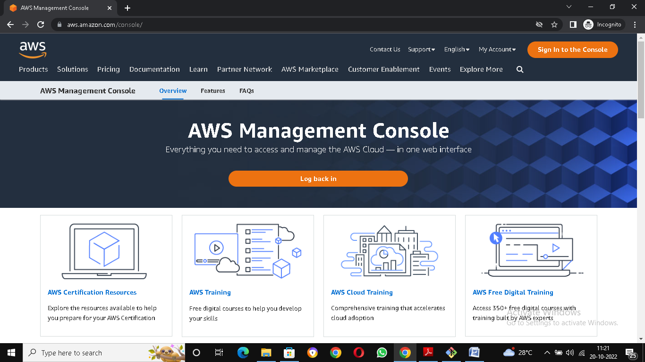
* Click on the sign in to the console
* Enter the user id and password

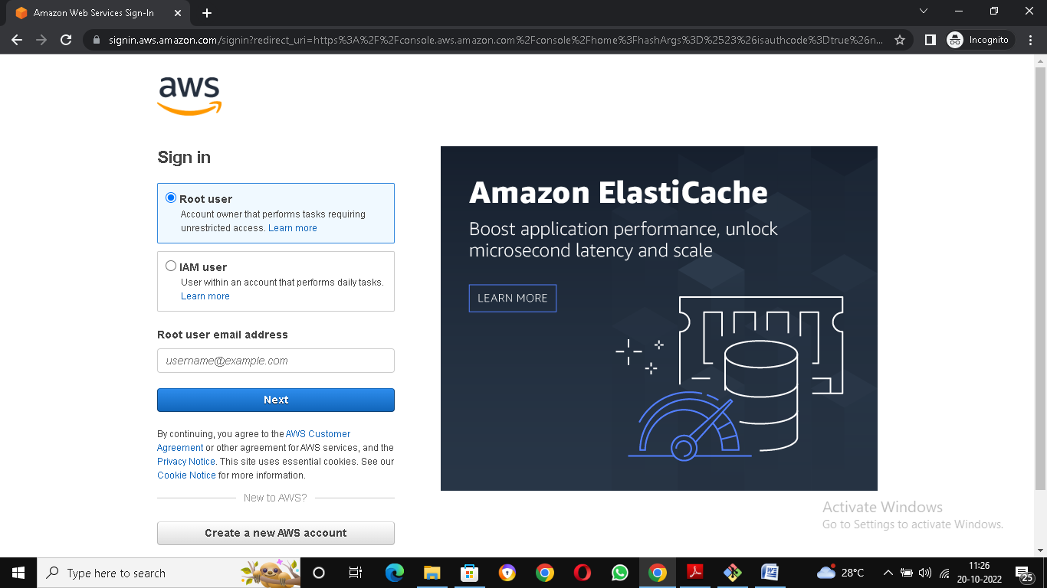

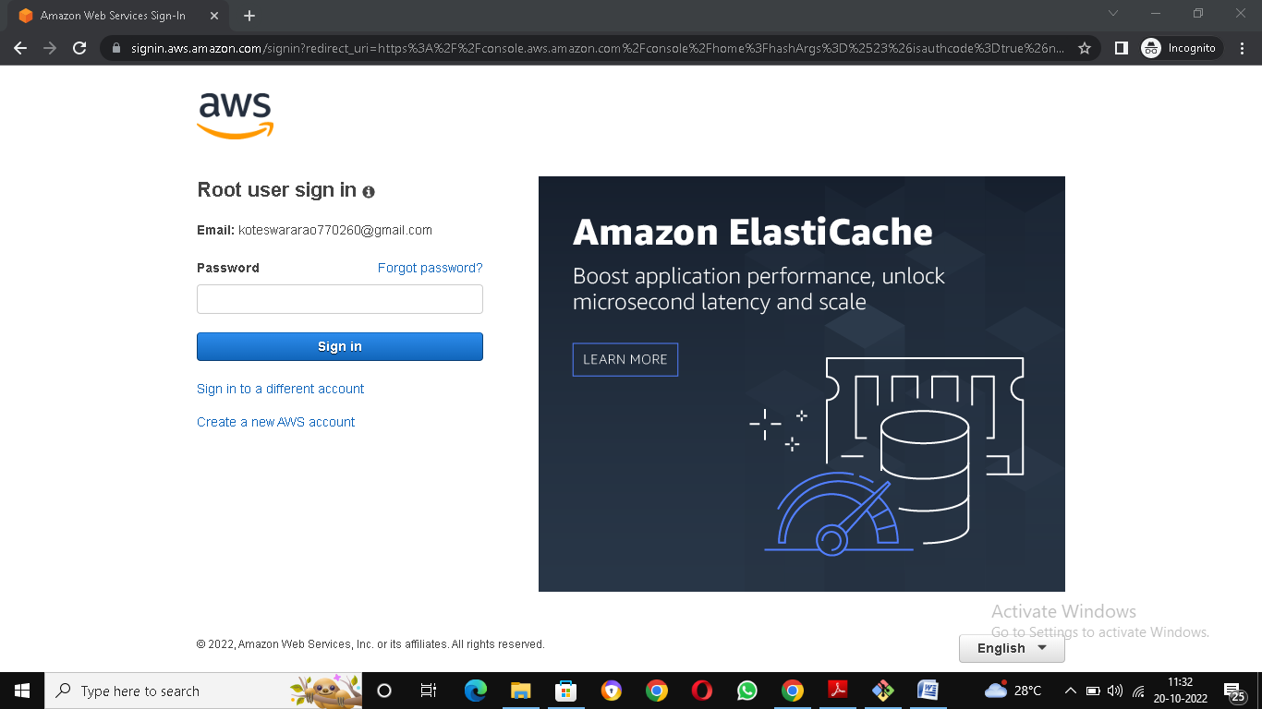

* Show the EC2 Dashboard

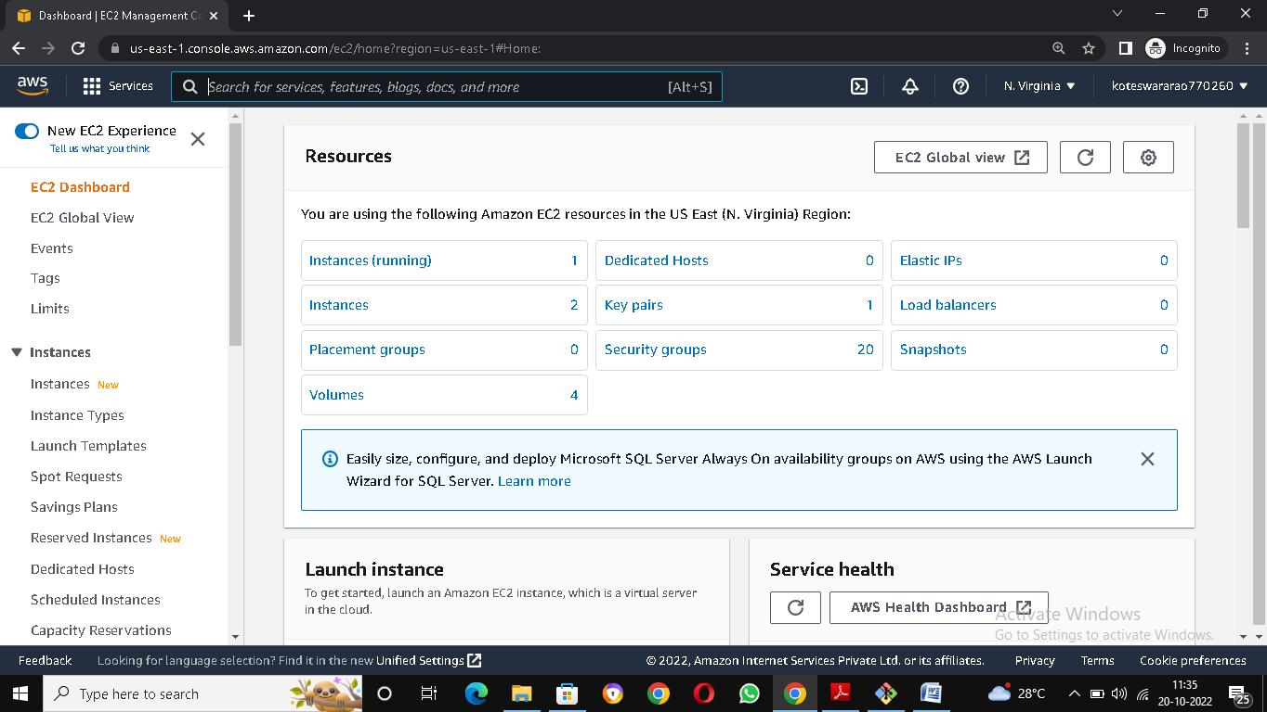

* Click on instance
* Click on launch instance

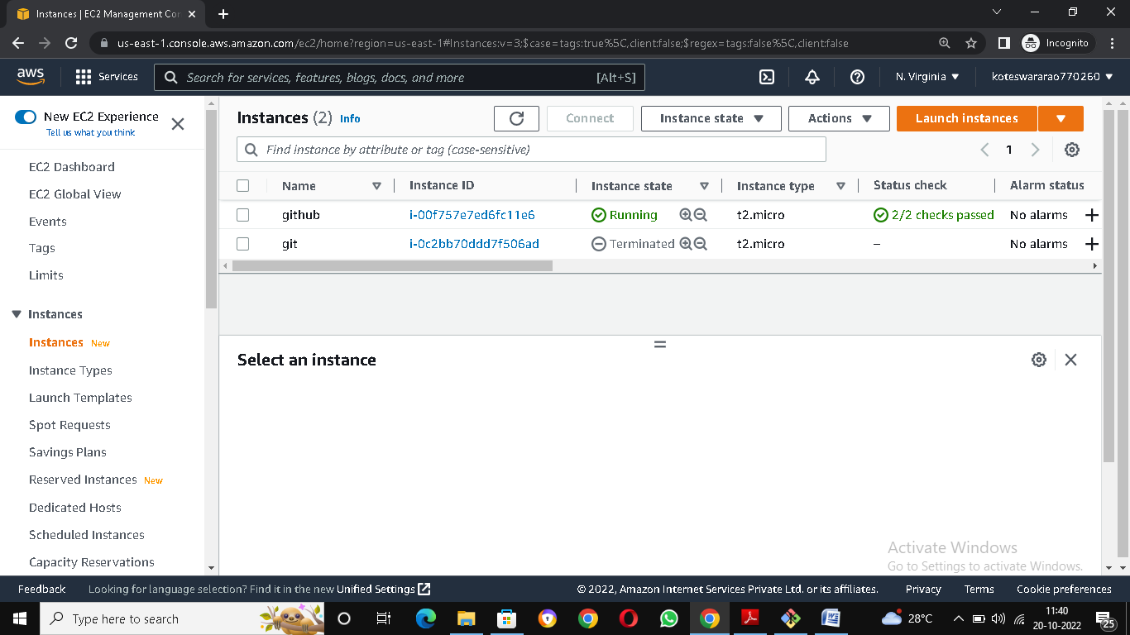

* Select instance AMI

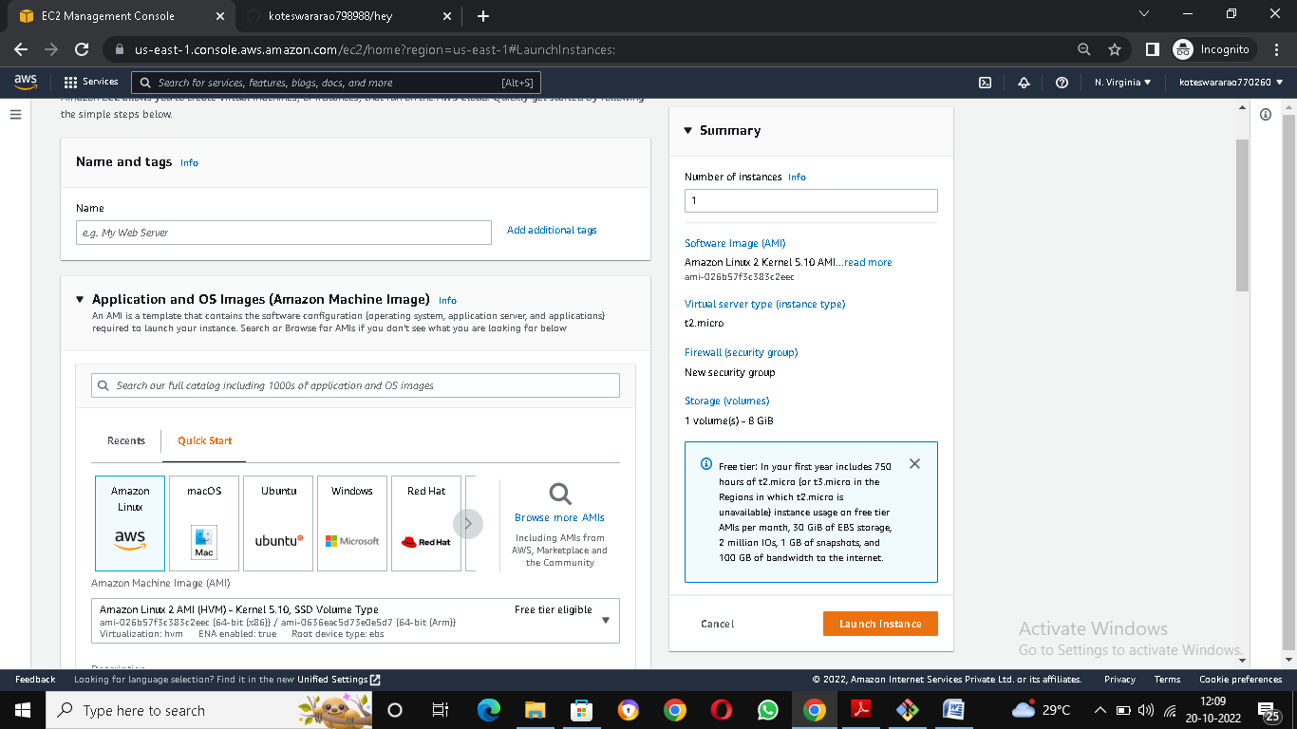

* Select Instance type and create key pair

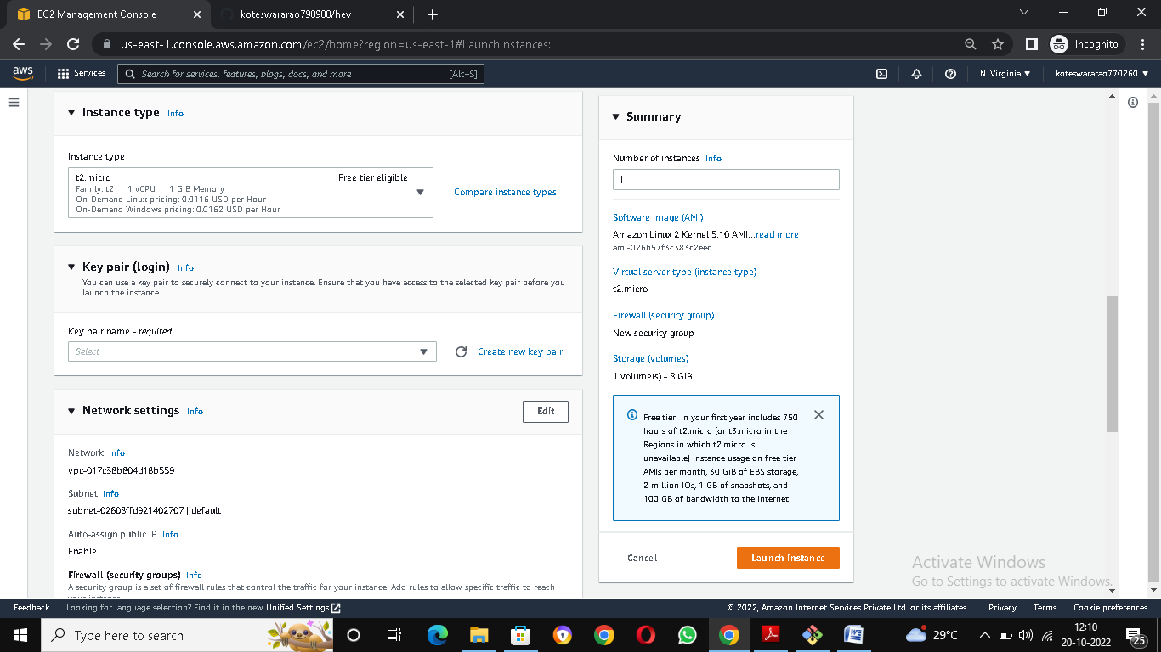

* Choose VPC and Sub net through Network settings

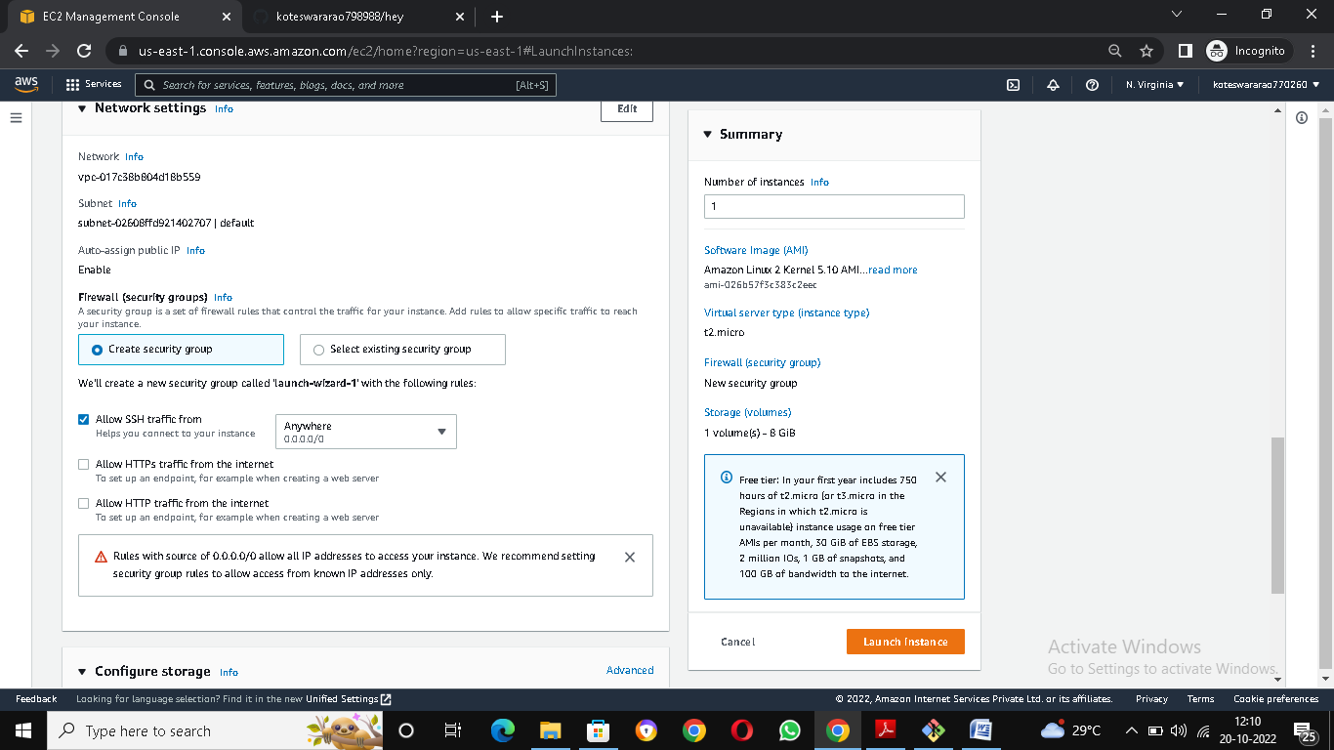

* Add storage and summary (for select the number instances)

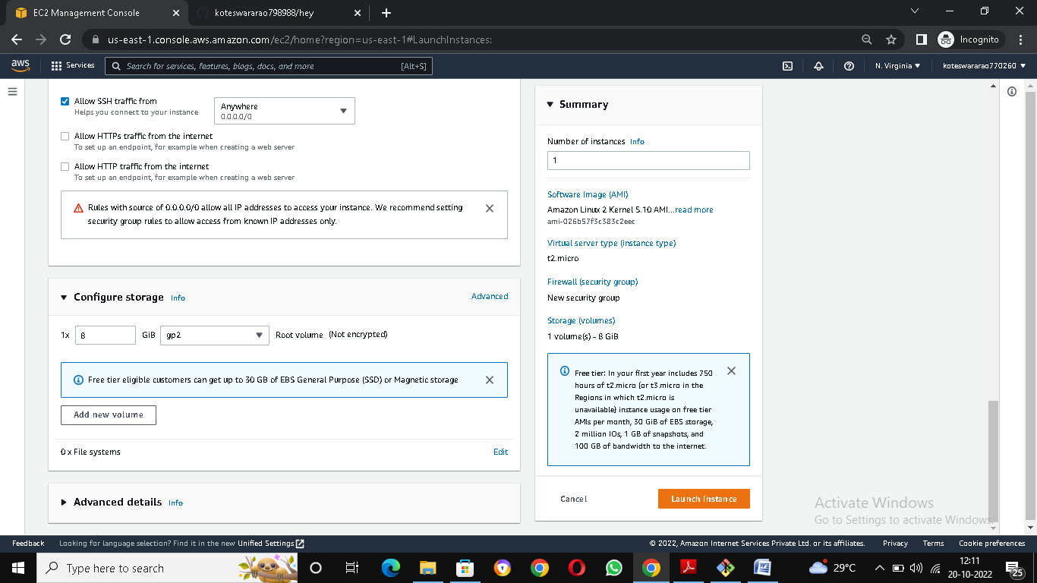

* Launch instance and copy SSH client from ec2 instance

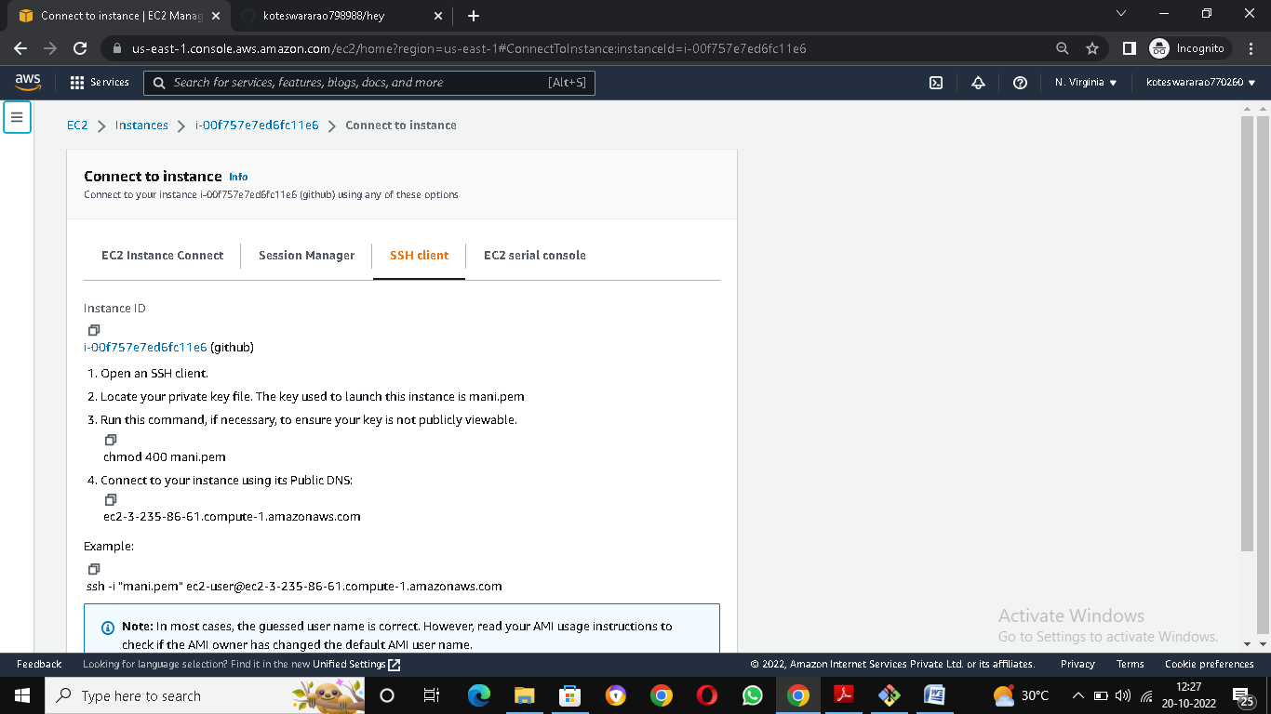

* Paste the SSh client address in GIT Bash

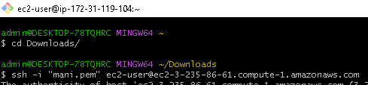

**Create repo in local machine**

* Install git in git bash terminal

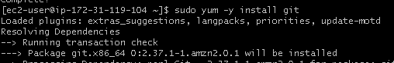

* Create folder in git bash

folder of local.PNG

* Go into folder by using command

cd local.PNG

* Create file
* File send from working directory to staging area
* And file send from staging area to local repo

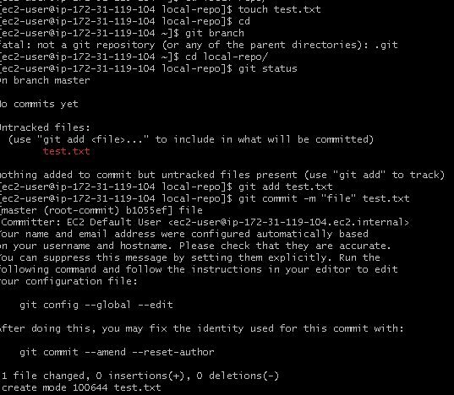

* Git status : show the woking Is free

git status.PNG

**Create repo in GITHUB**

* Go to the GIT HUB Login
* Click on sing in git
* Enter user id and password

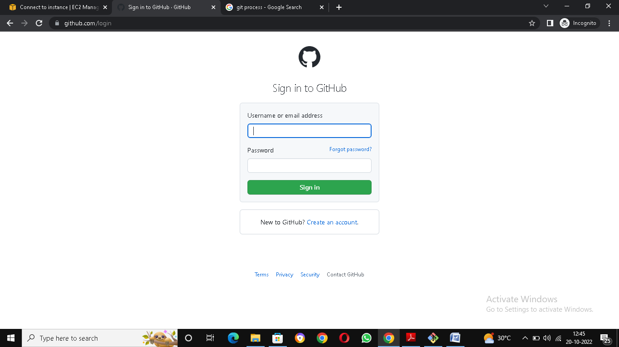

* Show the git hub dash board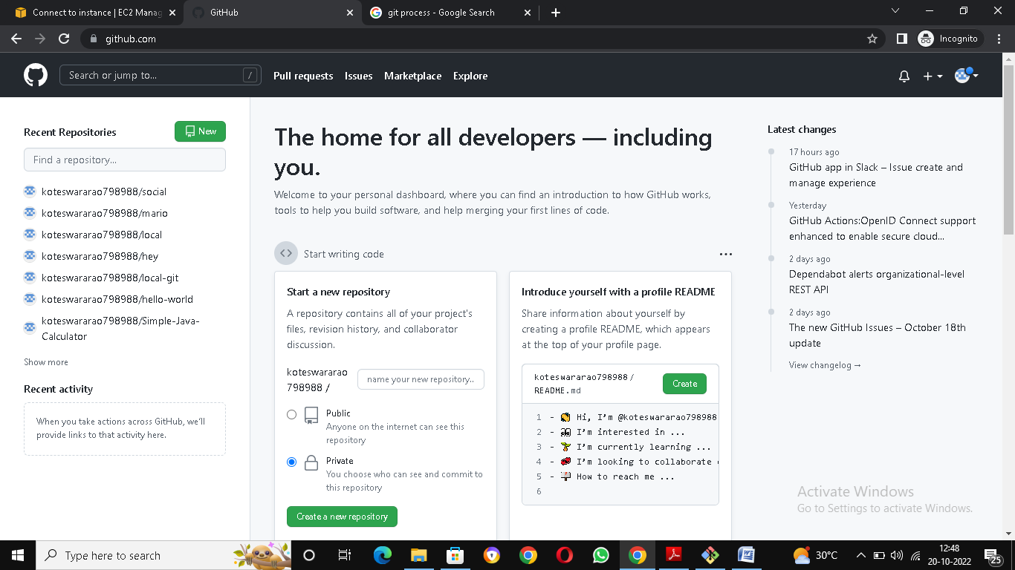
* Click on the new

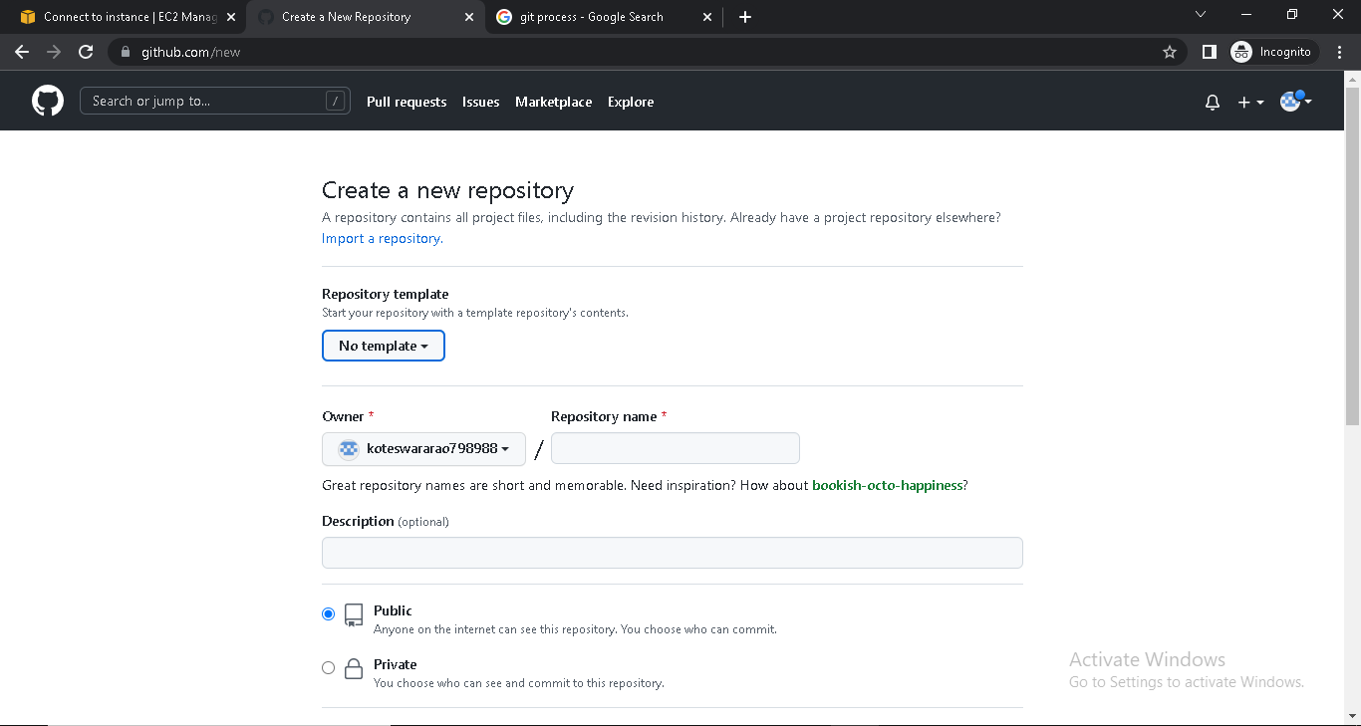

* Add README.File and create new repository

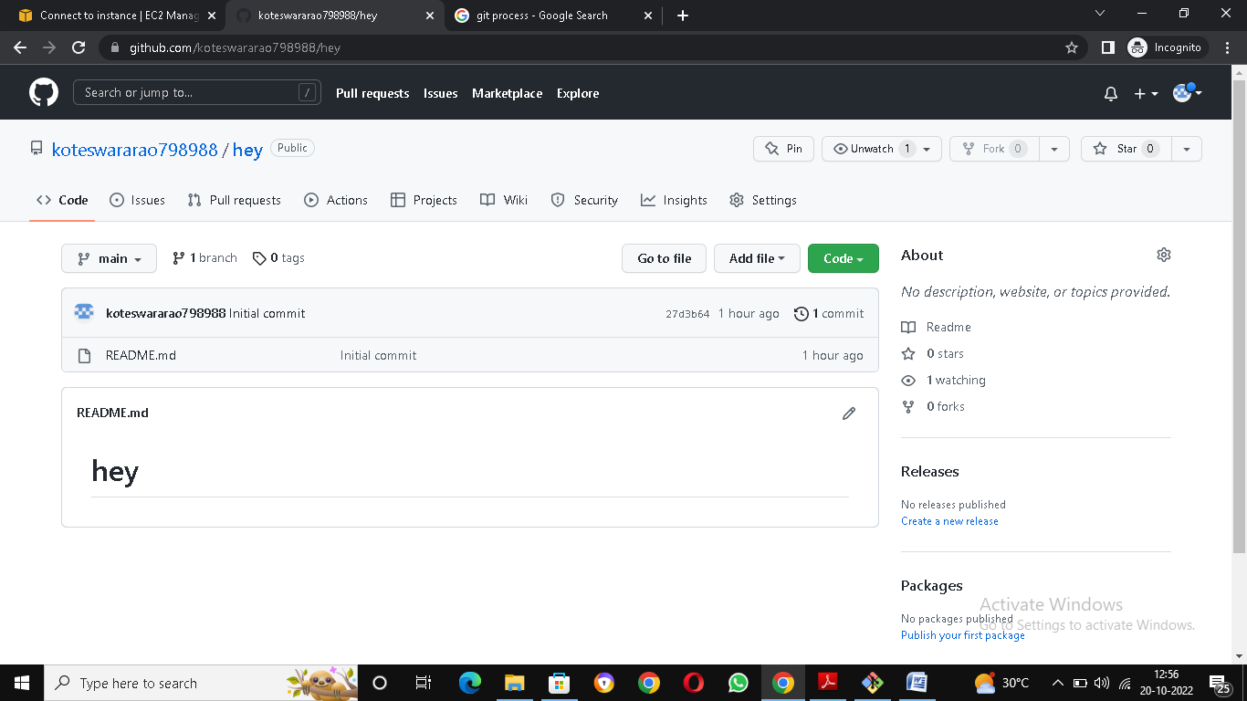

**Working with Remote Repo**

* Take the remote repo from git hub to git bash

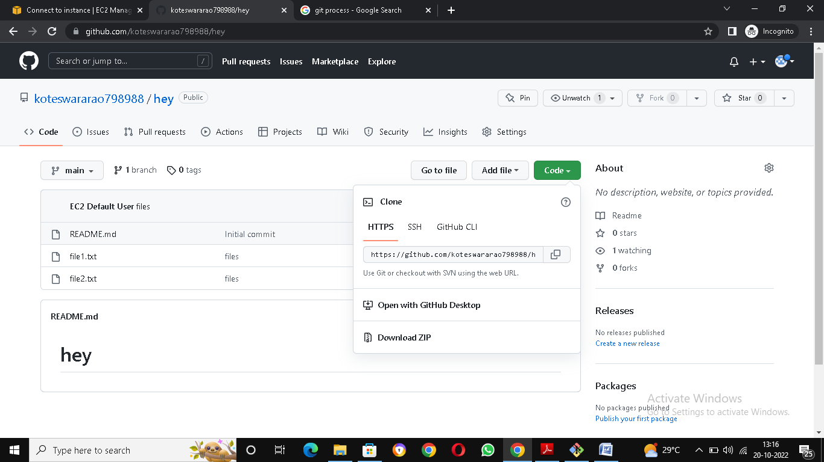

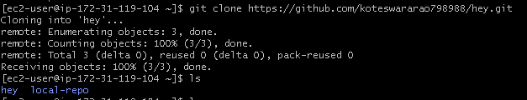

* Create files two or more

git add files.PNG

* File send from working directory to staging area
* And file send from staging area to local repo

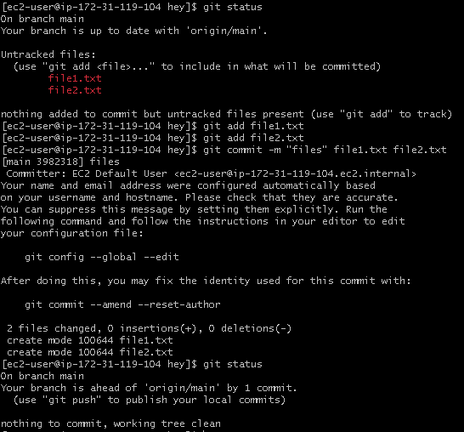

* Before push the files generate a git token for authentication
* Go to setting in github account

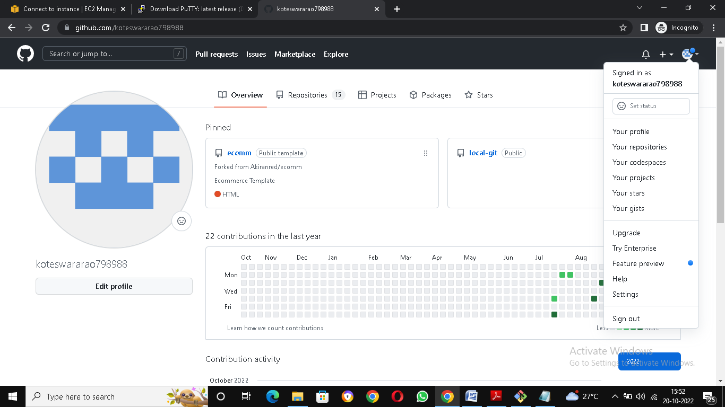

* Click on the developer settings

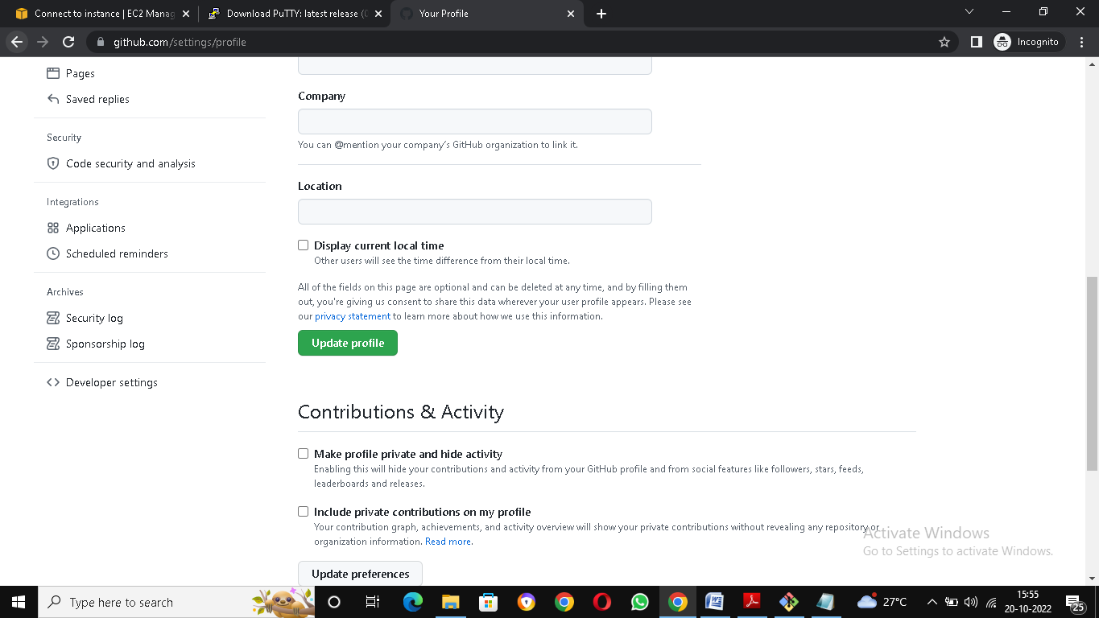

* Click on the personal access token and tokens

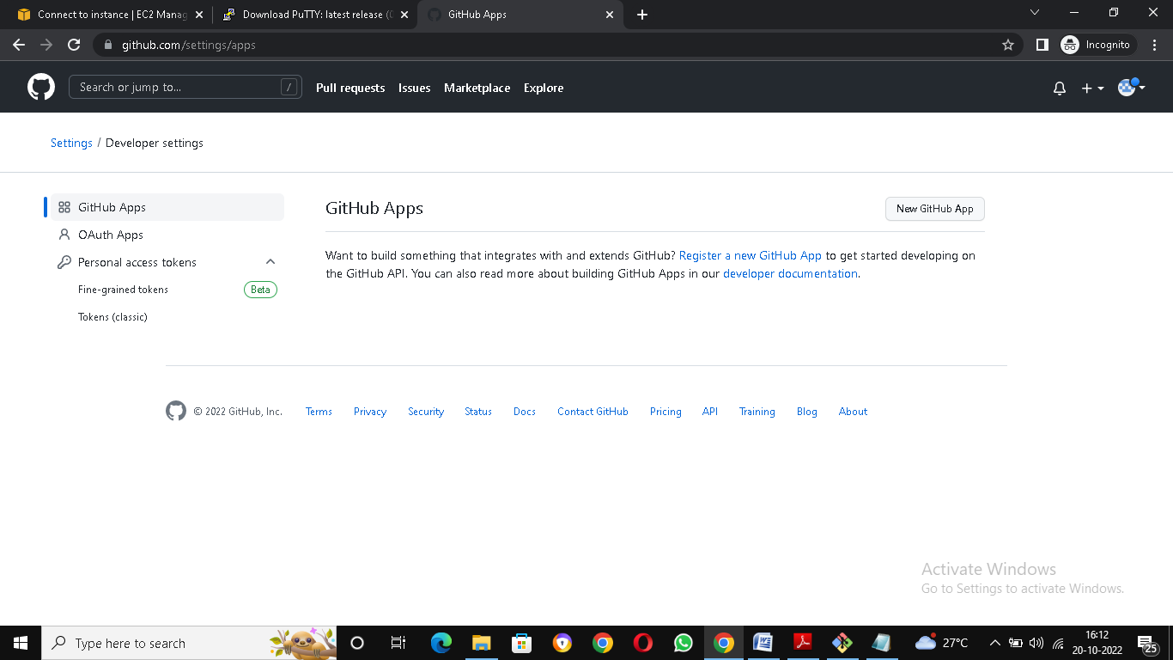

* Generate new token

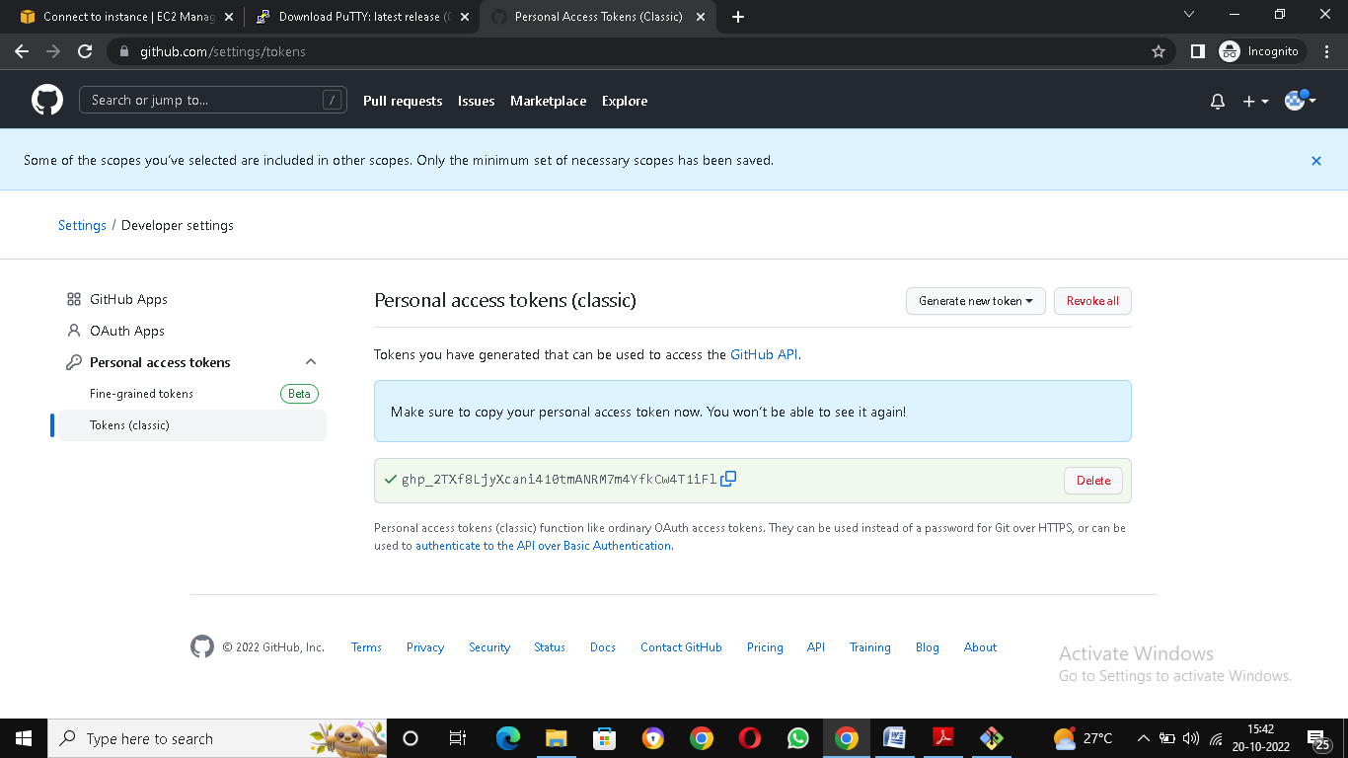

* Push the file from local machine to central repo

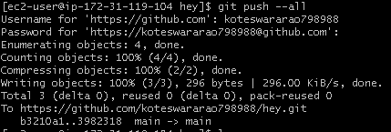

* Finally, we got the files in remote repo

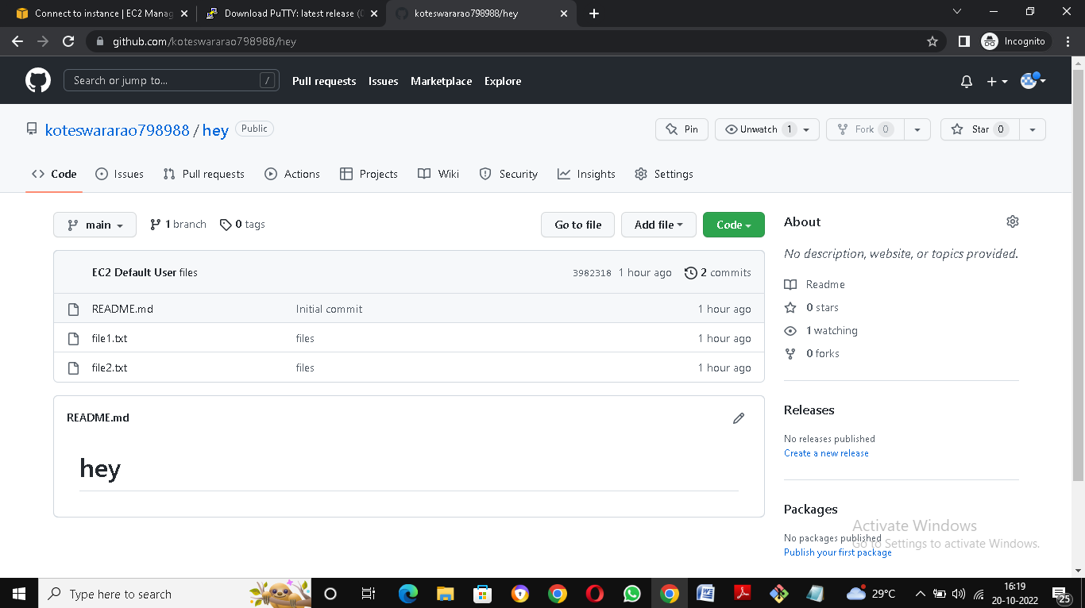

**Push Local Repo into GITHUB**

* Create one repo in local instance and initialize it locally

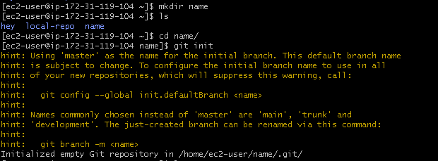

* Create remote repo with same name as local repo

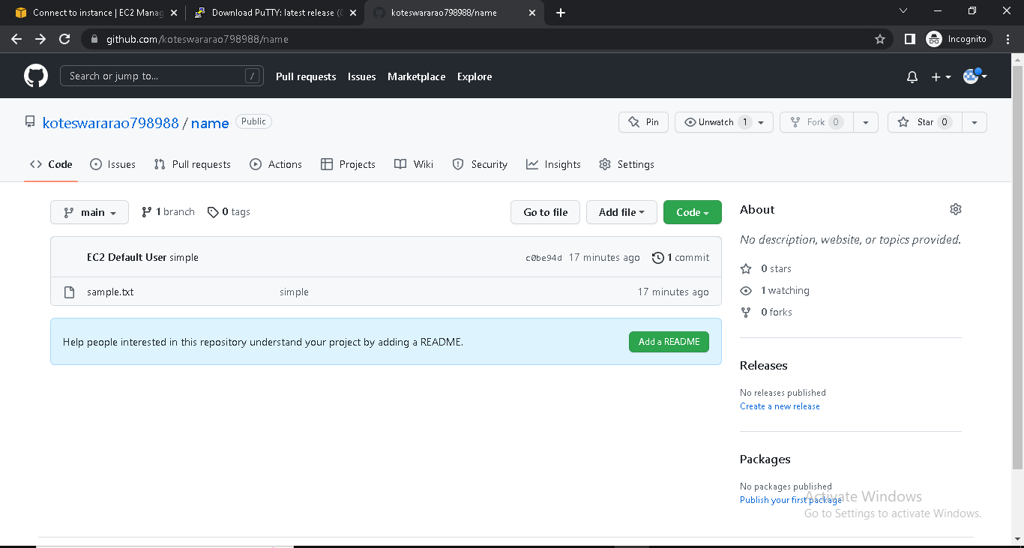

* Change name of git branch from master branch to main branch by using command (git branch –M main)
* git remote add origin <URL of your remote repo>
* push your local branch to remote repo(git push –u origin main)

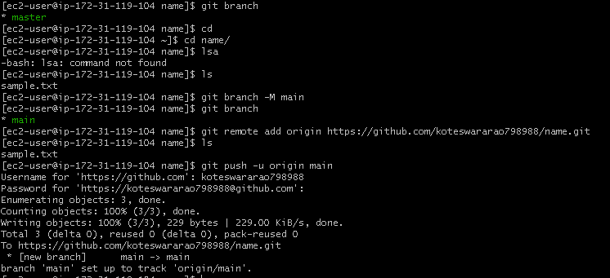

**Create a new Branch from your main Branch**

* Go to repository in git hub at the place of main and click on the branch dropdown

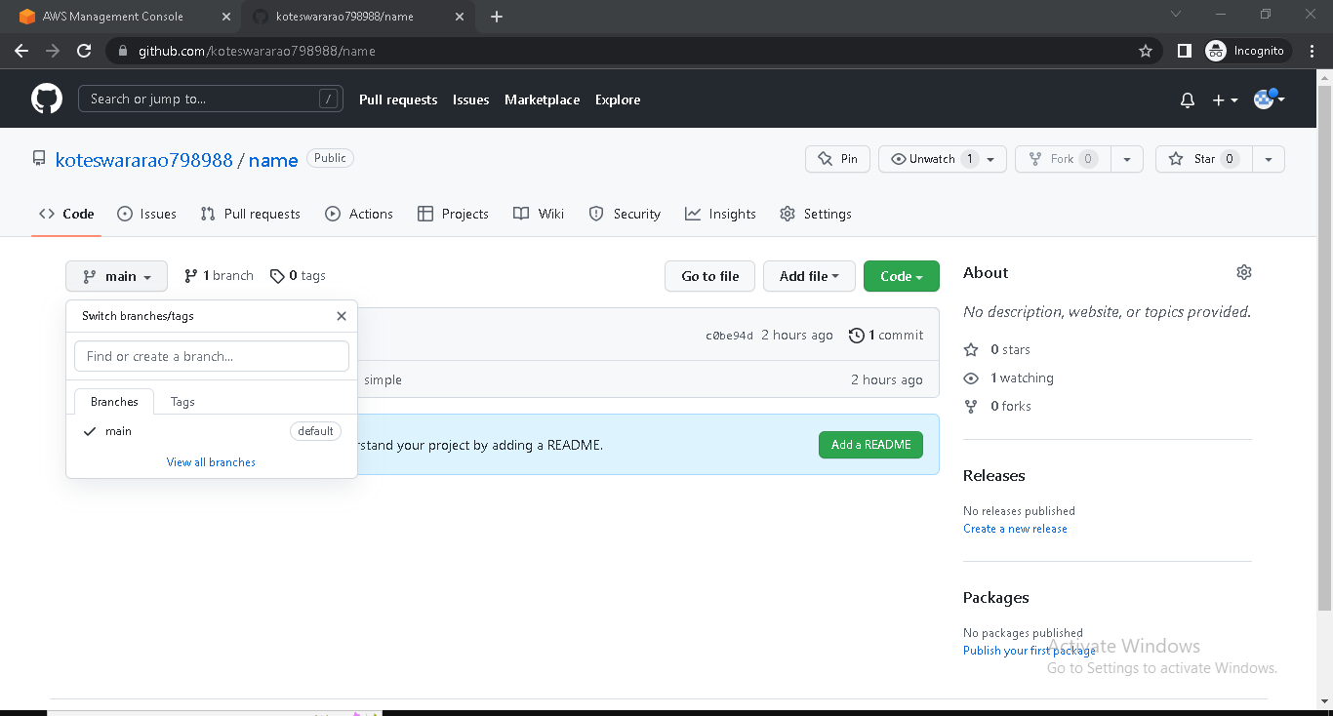

* Click on view all branches
* Create a branch

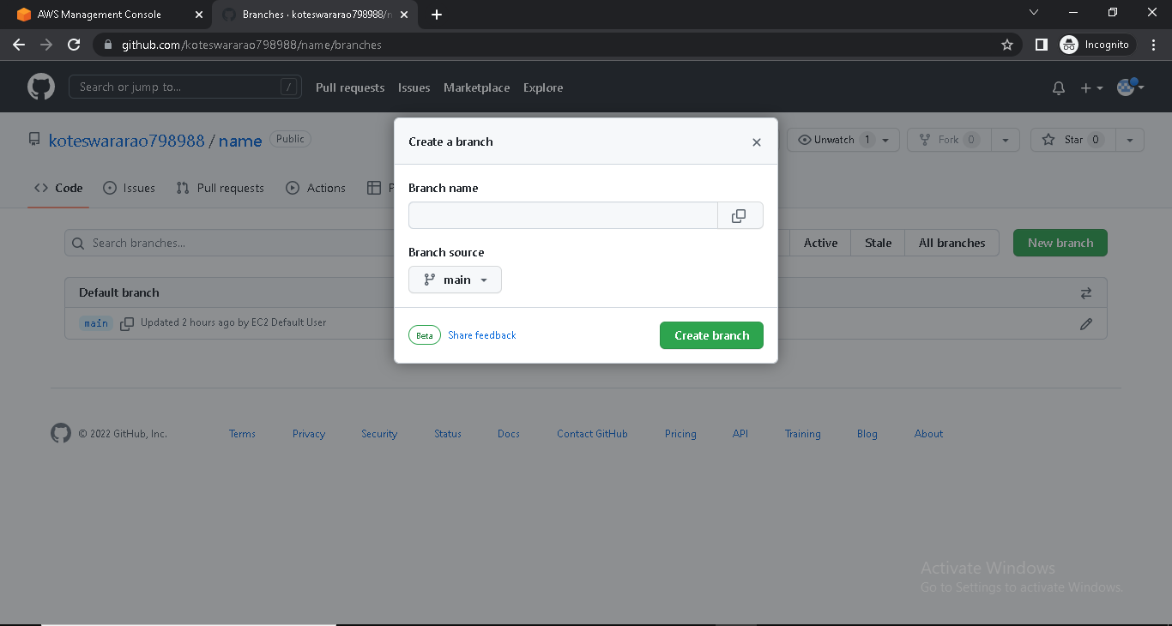

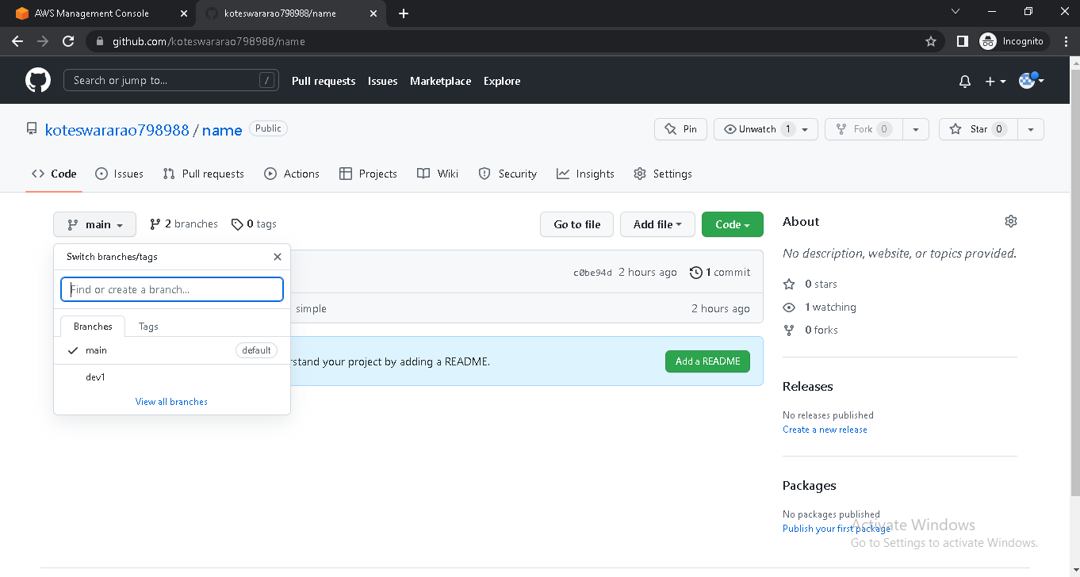

* Make some changes in new branch from console

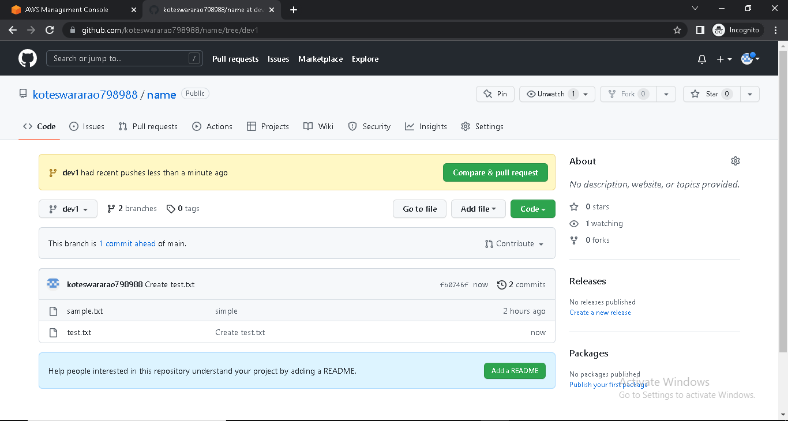

**Pull All Branches into Local machine**

* Pull the new changes from the remote location

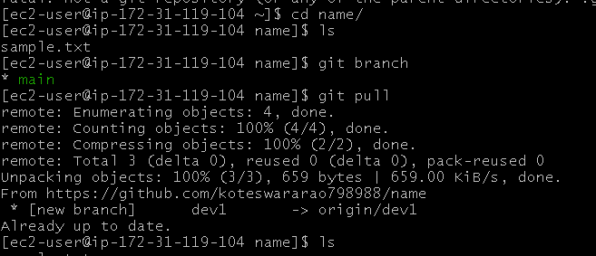

* See the list down all the branches

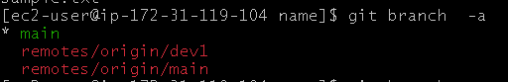

* Change the branch

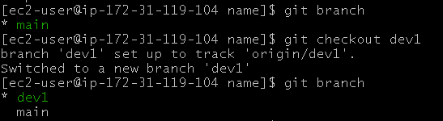

* Create files in new git branch

git dev add files.PNG

* File send from working directory to staging area
* And file send from staging area to local repo

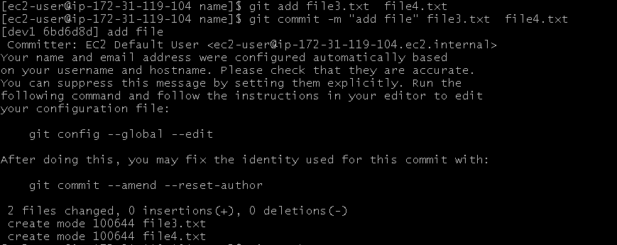

* Push files for local machine to remote repo

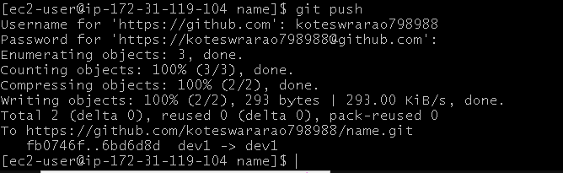

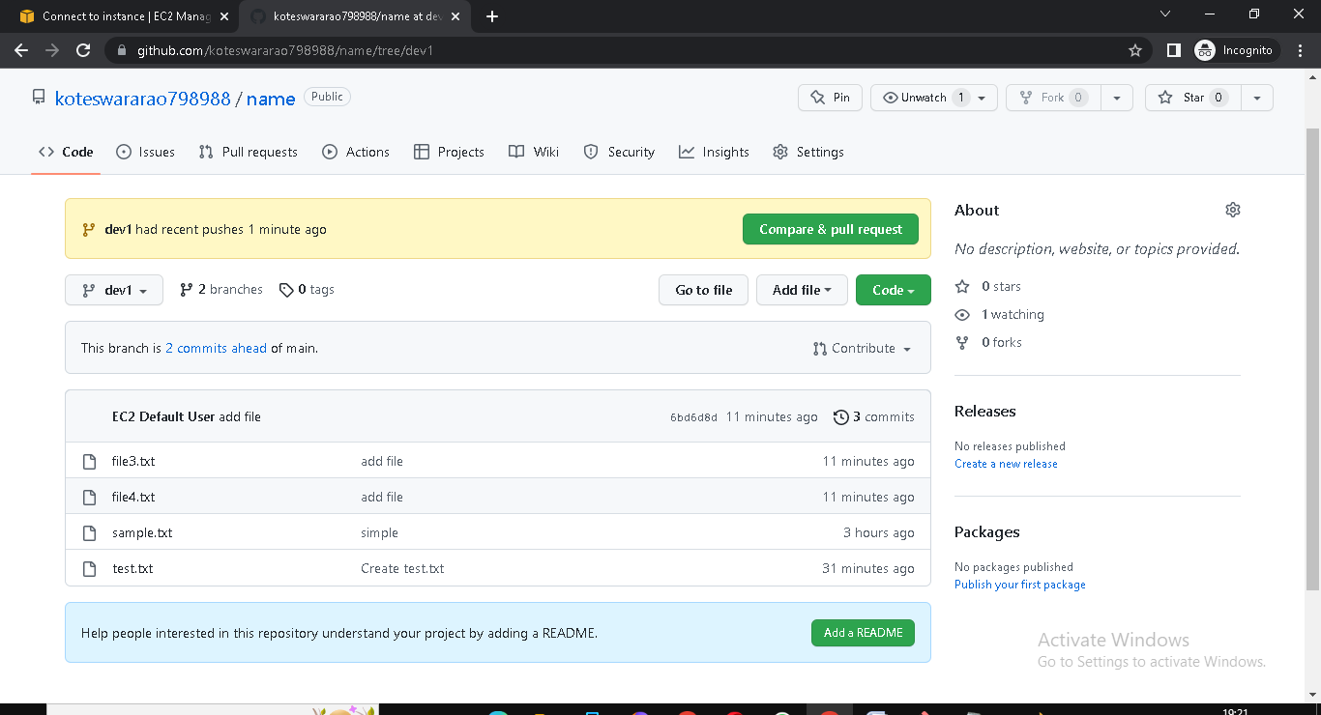

**Merge our feature Branch with Main Branch**

* Check the main branch file in remote repo

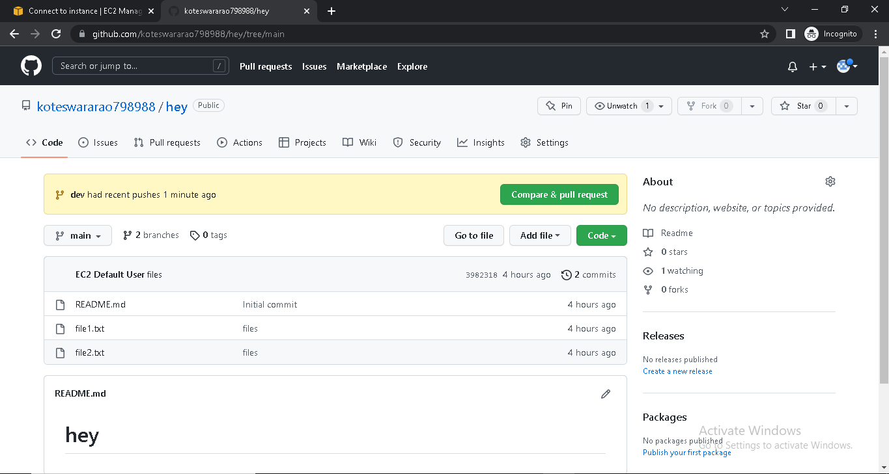

* Check the created branch files in remote repo

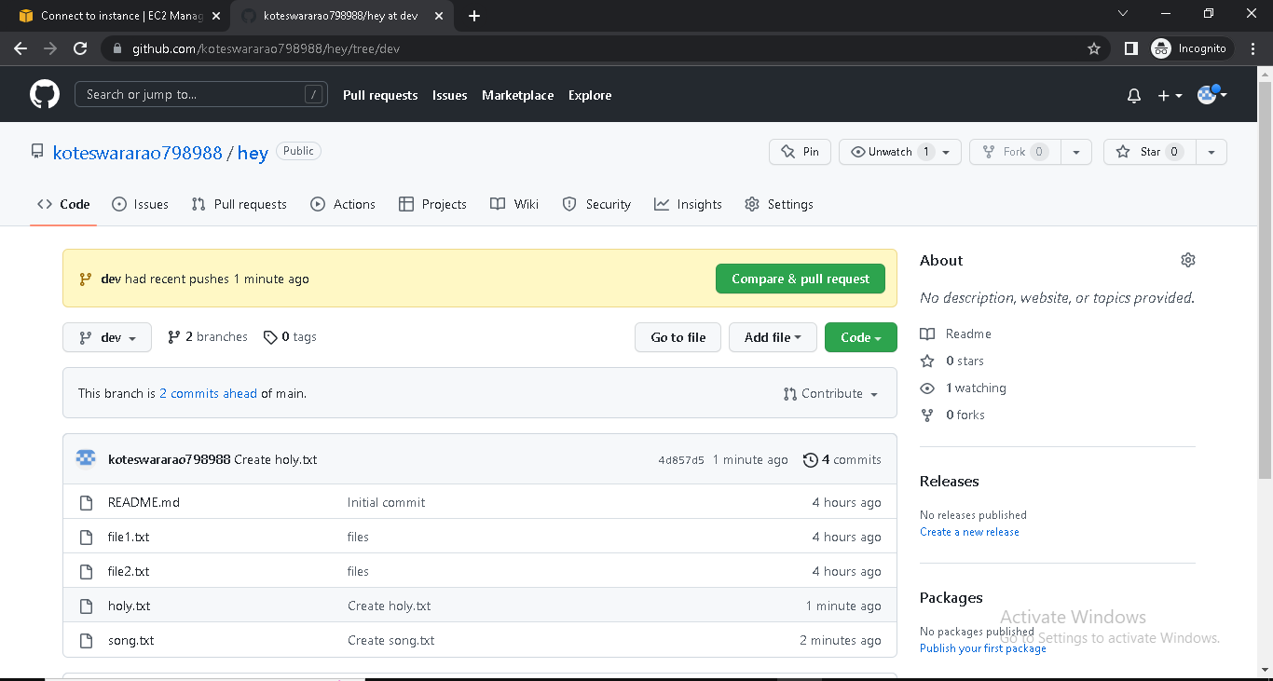

* Click on the pull request

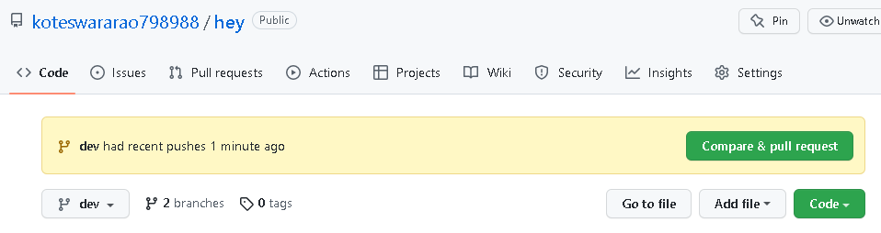

* Click on Create pull request

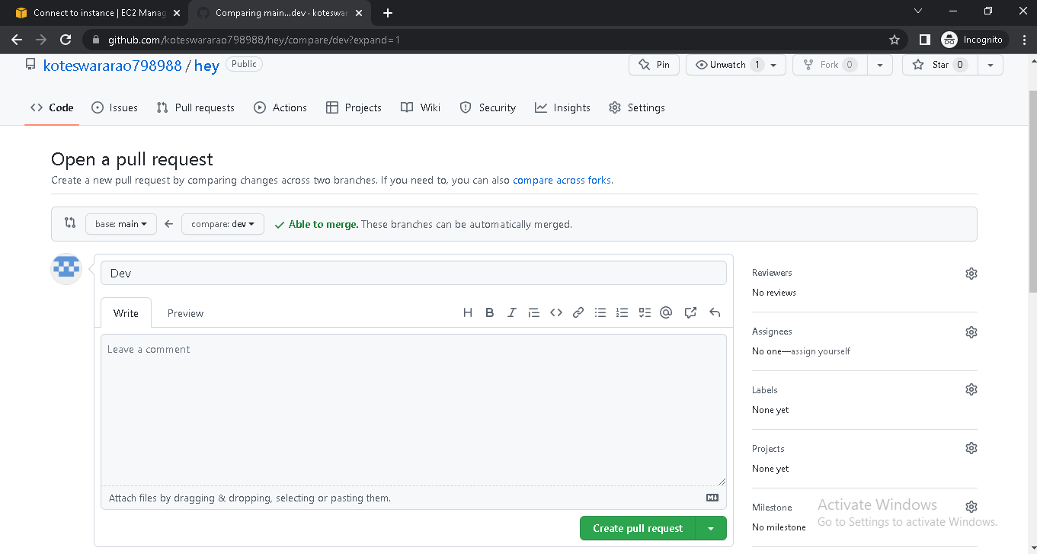

* Click on merge

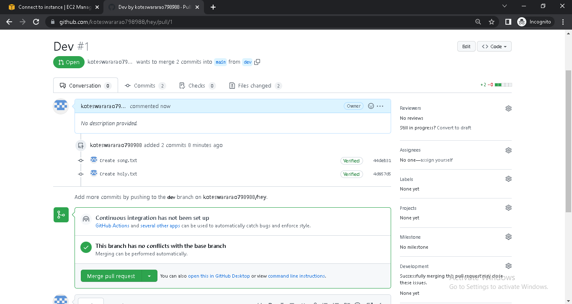

* Success the merge of main and created branch

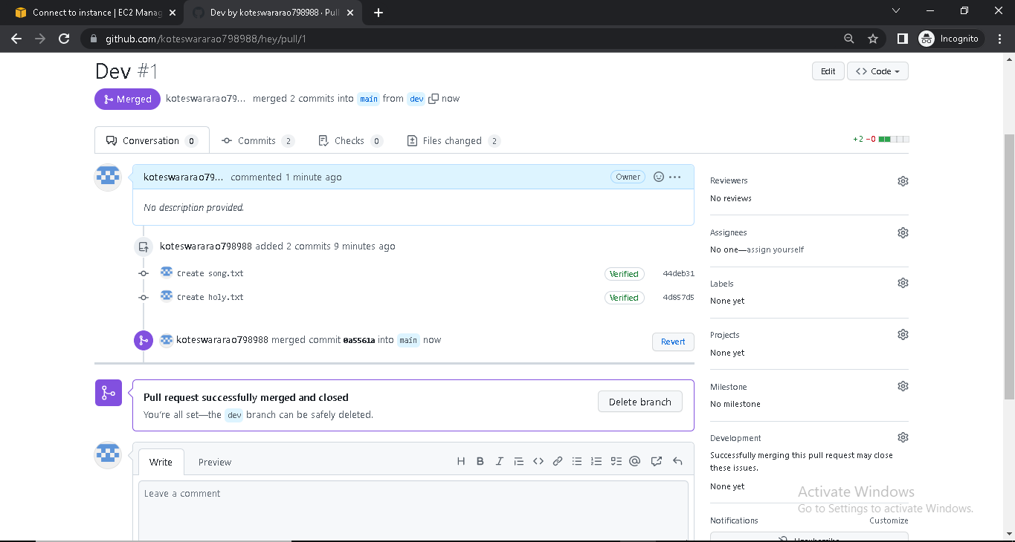

* Then go to code option
* Check the main branch

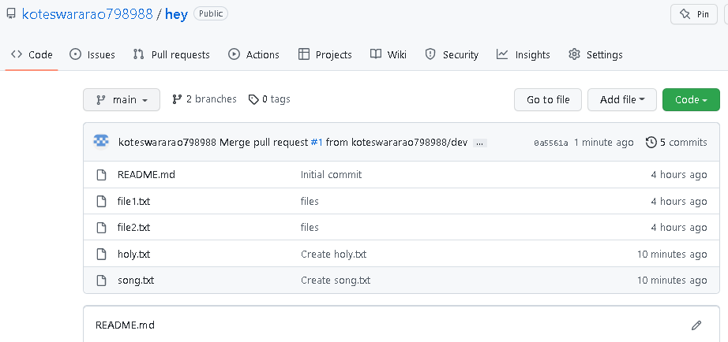

* Check the created branch

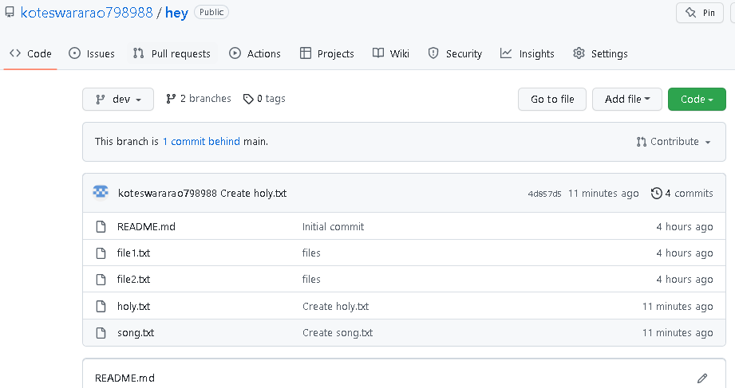

**New changes in main Branch**

* Go to Ec2 instance and go into the remote repo

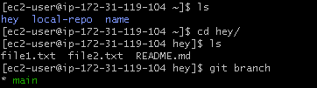

* Check out the main branch

gitbra min.PNG

* Run git pull for pull the new changes in main branch

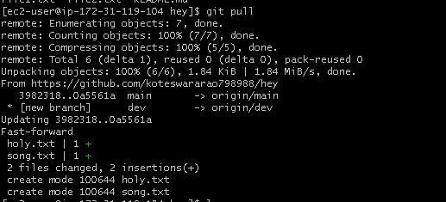

* Shows the main branch files

